AI Lab 9 Tasks

Name: Murtaza Hunaid Terai
Roll No.: 24K-0782
Section: BCS-4F

Task 1:

P(Red) = Red Cards/Total Cards = 25/52 = 1/2 = 0.5

P(Heart | Red) = Hearts/Red Cards = 13/26 = 1/2 = 0.5

P(Diamond | Face) = Diamond Face Cards/Total Face Cards = 3/12 = 1/4 = 0.25

P(Spade OR Queen | Face) = (3 + 4 – 1)/12 = 6/12 = 1/2 = 0.5
Task 2:

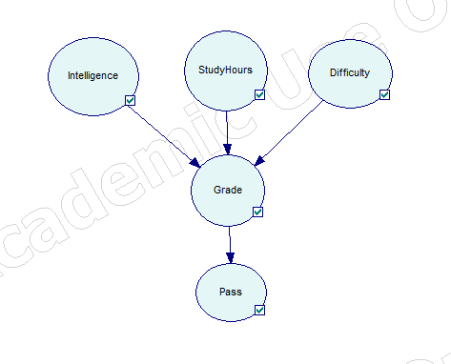
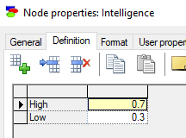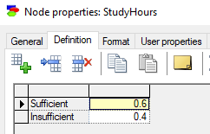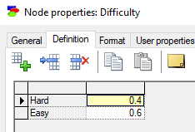
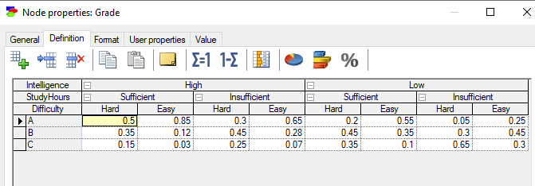
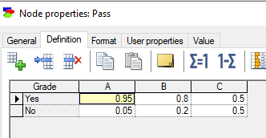

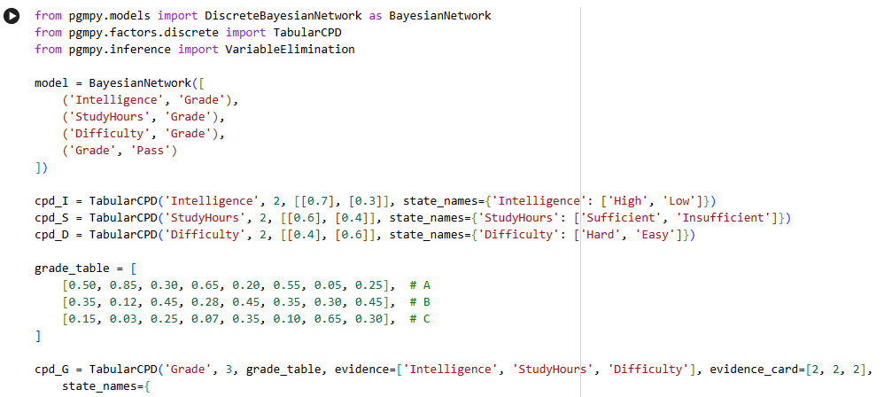
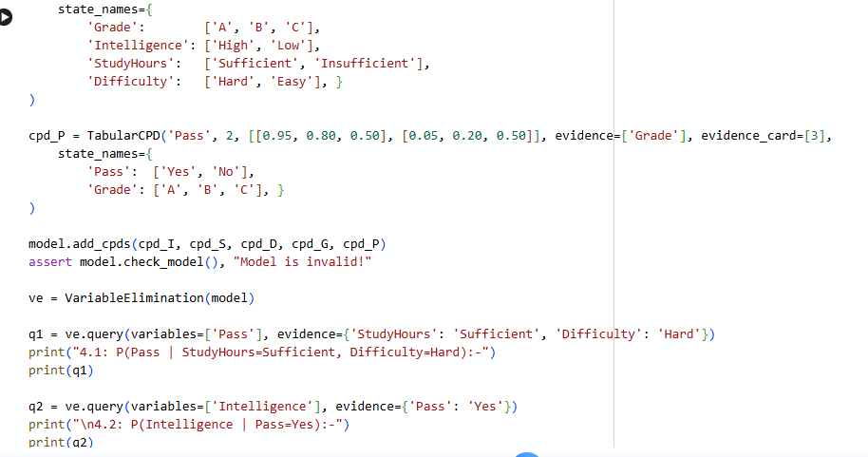
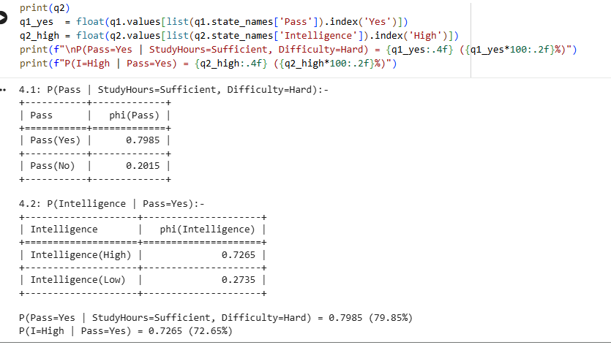

What is the probability that the student passes the exam, given:
StudyHours = Sufficient, Difficulty = Hard (In Genie using Bayesian Network):
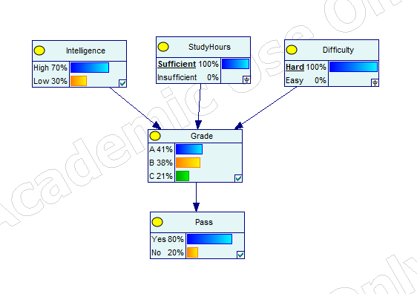
What is the probability that the student has High Intelligence, given:
Pass = Yes
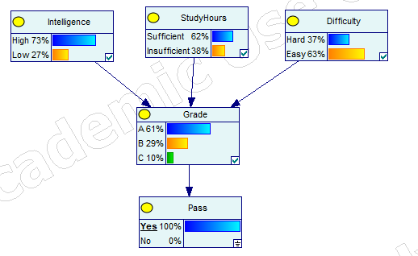
Task 3:

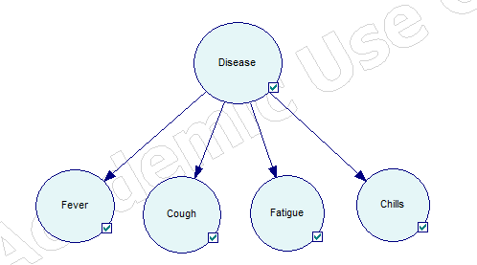
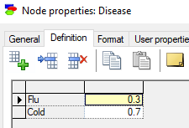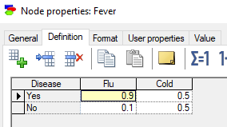
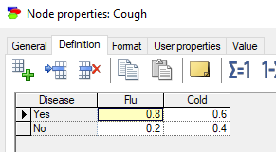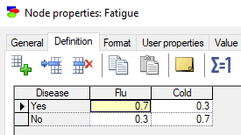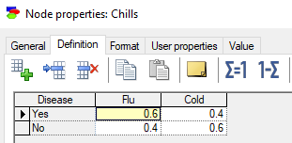
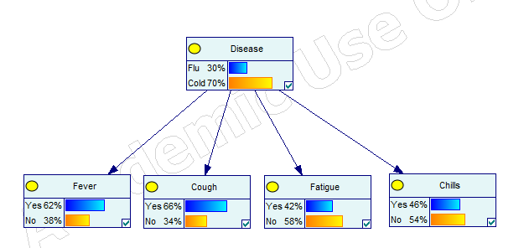

Inference Task 1:
Fever = Yes, Cough = Yes

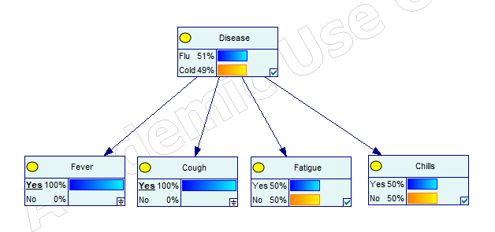
Disease:
Flu = 51%
Cold = 49%

Inference Task 2:
Fever = Yes, Cough = Yes, Chills = Yes
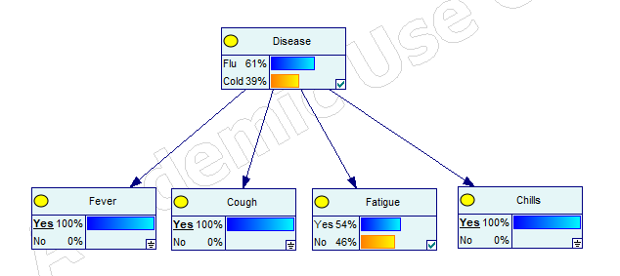
Disease: Flu = 61%, Cold = 39%

Inference Task 3:
What is P(Fatigue = Yes | Disease = Flu)?

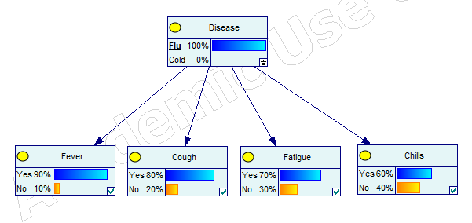
Fatigue: Yes = 70%, No = 30%

Task 4:

States:
- Sunny (S)
- Cloudy (C)
- Rainy (R)

Transition Matrix

From \ To | Sunny | Cloudy | Rainy
Sunny | 0.60 | 0.30 | 0.10
Cloudy | 0.30 | 0.40 | 0.30
Rainy | 0.20 | 0.30 | 0.50

